Assignment – 1
1. What is quality?
Answer- quality in software means delivering a product that meets customer needs, customer expectations, and requirements. Quality is about making sure the software is reliable, works as expected, and satisfies users. quality software is easy to use, does what it’s supposed to, and performs well in different situations.

2. Difference between QA and QC?
Answer- Here’s a comparison between QA and QC in a tabular format:
Quality Assurance (QA) | Quality Control (QC)
Improves process | Identifying defects in the product
Prevent defects | Detect defects
Came to picture before development | Came to picture after development
They are tester/dev’s | They are testers
Process oriented | Product oriented
Following coding standards | Performing functional tests
Part of development lifecycle | Part after development
Covers entire development process | Focuses only on the final product

3. Define errors, bugs and defects?
Answer- Error- A mistake made by the developer during coding, such as a typo or logic mistake.
Suppose in the code, return x - y is written instead of return x + y.
Its developer’s mistake during the coding process.
- Bug-The incorrect behavior or output found during testing due to the developer’s error.
Suppose a tester finds that add_numbers(5, 3) returns 2 instead of 8.It’s tester’s responsibility to identify bugs during testing.
- Defect-A flaw or mismatch from the requirements, found by the user after release if the bug wasn’t fixed . Suppose a user tries to add numbers in the app and gets incorrect results, realizing the feature doesn’t work as expected.

4. What are the benefits of QA?
Answer- Quality Assurance (QA) helps make software better. It checks that the product is good and meets standards. This means there are fewer mistakes and happier users.
Finding problems early saves money. Fixing things after release can be expensive. When QA is done well, customers are happier and leave good reviews.
QA also helps teams work together better. It sets up easy ways to do things. It finds potential problems before they get too big, which is really helpful.
QA encourages developers and testers to talk more. This way, they can fix issues faster. It also helps teams learn from their mistakes and improve.
So, adding QA to the development process helps companies make better products, save money, and keep customers happy

5. What are the basic testing principles?
Answer-
Early Testing: Testing should start as early as possible in the development process to catch issues before they become big problems.
Defect Clustering: Most defects are often found in a small number of modules, so focus on those areas during testing.
Pesticide Paradox: Running the same tests over and over won't find new bugs. It's important to change and create new test cases to catch more defects.
Testing Shows Presence of Defects: Testing can show that defects are present, but it can’t prove that there are no defects at all.
Exhaustive Testing is Impossible: It’s not feasible to test everything. Instead, prioritize testing based on risk and critical features.
Continuous Improvement: Testing processes should be constantly reviewed and improved to make them more effective and efficient.
Testing is Context-Dependent: The testing approach should be based on the specific context of the project, including its goals, technology, and risks involved.

6. Explain various phases of SDLC?
Answer- SDLC includes thease phases
- Planning: This is where the project is defined. Goals, scope, resources, timelines, and budgets are established. The team identifies the requirements and assesses the feasibility of the project.
- Requirements Gathering and Analysis: In this phase, detailed requirements are gathered from stakeholders. This includes functional and non-functional requirements. The team analyzes these requirements to ensure they are clear and complete.
- Design: Here, the system architecture and design specifications are created based on the requirements. This includes high-level design (HLD) and low-level design (LLD), which outline how the system will be built.
- Implementation (Coding): In this phase, developers write the actual code based on the design documents. This is where the software starts taking shape.
- Testing: Once the code is developed, it's tested to find and fix defects. Various testing methods are used, such as unit testing, integration testing, system testing, and acceptance testing.
- Deployment: After testing is complete and the software is deemed ready, it is deployed to the production environment where users can access it.
- Maintenance: This is the final phase, where the software is monitored for issues, updates, and enhancements. It ensures that the software continues to meet user needs and remains functional over time.

7. Define Pareto Principle?
Answer- 7. Define Pareto Principle?
The Pareto Principle also known as the 80/20 Rule, is the idea that roughly 80% of effects come from 20% of causes. In other words, a small number of factors often have a large impact.meaning that 80% of the defects in a product are usually caused by just 20% of the issues. Identifying and focusing on these key areas can help teams improve quality more effectively.if a software application has many bugs, the Pareto Principle suggests that a few specific bugs might be responsible for most of the problems users experience.
principle encourages prioritization, allowing teams to focus their efforts on the most critical areas for maximum benefit.

8. Difference between verification and validation?
Answer-
Verification | Validation
Checking if the software meets specified requirements during development. | Evaluating the finished product to ensure it meets user needs.
focus on processes and development artifacts, like requirements and design documents. | focus on the final product and its functionality.
Occurs throughout the development cycle | Performed after the product is complete.
Includes reviews, inspections, analysis of documents and code. | Includes dynamic testing, user acceptance testing, and performance testing.
Aims to find errors in the software development process. | Aims to find errors in the software product itself.

9. What is the Full form of ISO?
Answer- The full form of ISO is the International Organization for Standardization.
ISO is an independent, non-governmental international organization that develops and publishes standards to ensure quality, safety, efficiency, and interoperability of products, services, and systems across various industries. These standards help organizations improve their operations, enhance customer satisfaction, and facilitate international trade by ensuring compatibility and quality assurance.
ISO standards cover a wide range of topics, including quality management (like ISO 9001), environmental management (ISO 14001), and many others.
10. Explain Budgets for QA / Cost of QA (Graph)
Answer- Budgets for Quality Assurance (QA) are the money set aside to make sure that software meets quality standards during development. This budget is important for managing the costs of different QA activities.
The main costs in QA include personnel costs, which cover salaries and benefits for QA team members like testers and managers. There are also costs for the tools and software used for testing. Training costs are included for teaching staff how to use these tools properly. Testing activities, like unit testing and user acceptance testing, also add to the budget.
Another big part of the budget is defect management, which is about the costs of finding, fixing, and checking defects during testing. Money is also spent on improving QA processes and doing quality audits.
The total cost of QA is important because it shows how much a company invests in quality. Spending on QA is helpful because it can lower the overall cost of defects. Catching and fixing problems early in the development process is much cheaper than fixing them after the software is released. By investing in QA, companies can make better software and keep their customers happy, making it an essential part of the development budget.
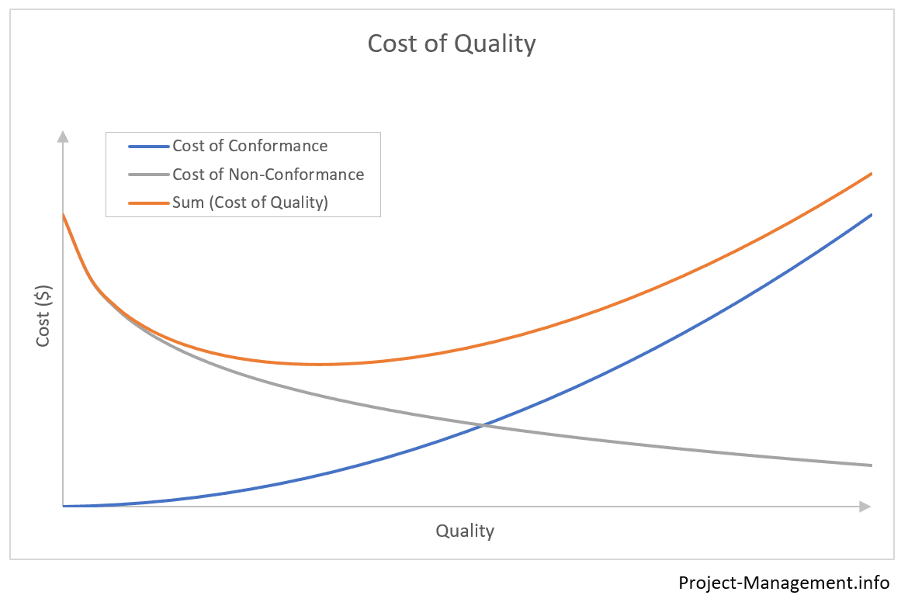
11. What is Test Case?
Answer- A test case is a set of steps that a tester follows to see if a software application works correctly. It helps make sure the software meets its requirements and functions as expected.
A test case usually includes:
- Test Case ID: A unique number or name for the test case.
- Description: A short explanation of what the test case checks.
- Preconditions: Any setup needed before running the test.
- Test Steps: A clear list of actions to take during the test.
- Expected Result: What should happen after doing the test steps.
- Actual Result: What really happened when the test was run; this is filled out during testing.
- Status: Tells whether the test passed or failed.

12. What are Audits and inspections?
Answer- Audits and inspections are ways to check the quality of software and the development process, but they serve different purposes. Audits are formal reviews done by an independent team or outside party. They focus on processes and systems to ensure everything follows the right standards and rules, helping to identify areas for improvement. Inspections, on the other hand, are detailed checks of specific items, like code or design documents. Team members review each other’s work closely to find defects early on. Both audits and inspections are essential for maintaining software quality; audits ensure processes are followed correctly, while inspections help catch and fix problems in the actual work.

13. What is Alpha, beta testing and QA?
Answer-Alpha Testing is the first phase of testing where the software is tested by internal staff, usually in the development environment. This testing happens before the software is released to real users. The goal of alpha testing is to find bugs and issues early, so they can be fixed before the product goes to beta testing. Testers check the software's features, usability, and performance to ensure it meets the required standards.
Beta Testing comes after alpha testing and involves real users testing the software in a real-world environment. This phase is important because it helps gather feedback from actual users, who may use the software differently than the development team. Beta testing helps identify any remaining issues before the final release. Testers provide feedback on the software's functionality, performance, and any bugs they encounter.
Quality Assurance (QA) is the overall process of ensuring that software is developed to meet certain quality standards. QA includes various activities, such as planning, designing tests, executing them, and reviewing the results. It focuses on preventing defects and ensuring the final product is reliable and meets user needs.

